Geometry: Unit 7, Lesson 9

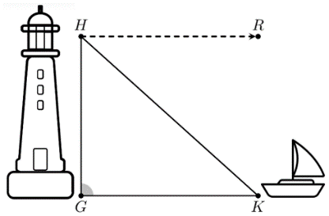
- A man sees a boat in the water, at point $K$, from the top window of the lighthouse, at point $H$. The height of the lighthouse window is $20$ meters above the water. The boat is $30$ meters away from the base of the lighthouse, $G$. How far away is the person from the boat?

Approximately 36 meters

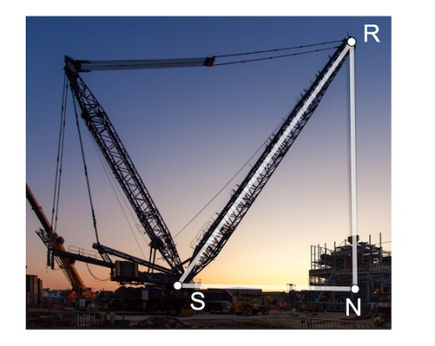

- The crane shown has two arms to lift heavy objects. One arm of the crane, $\overline{RS}$, has a length of $15$ meters. The crane’s arm makes a $56°$ angle with the ground. What equation can be used to find the length of $\overline{RN}$?

$$\sin\left(56°\right)=\frac{RN}{15}$$
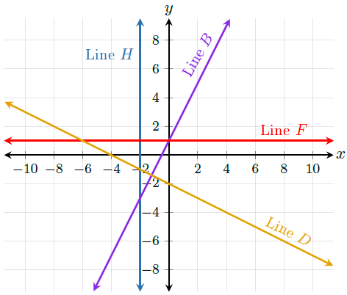
- Lines $H$, $B$, $F$, and $D$ are shown on the coordinate grid. Which of the lines has a zero slope?

Line $F$

